Blind-hole subtraction

Definition
# Source: AI Source: Provided by: [Data Path: Persons Table -> ID Column: 1, Name_En Column: Motasem Essam] -> From: [ChatGPT] on [7/25/2026]
Blind-Hole Subtraction is a method of modifying a solid by removing material from one of its surfaces to create a hole or opening that extends only partially into the solid and does not pass completely through it.
The hole has an entrance on the original solid's surface and a closed bottom inside the solid.
A blind hole may have a cylindrical, rectangular, square, triangular, polygonal, or other cross-sectional shape.
Simple Definition: Blind-hole subtraction is the process of removing material from a solid to create a hole that has a closed end inside the solid.

Geometric Representation
# Source: AI Source: Provided by: [Data Path: Persons Table -> ID Column: 1, Name_En Column: Motasem Essam] -> From: [ChatGPT] on [7/25/2026]
A blind hole is characterized by:
- An opening on the external surface.
- A defined depth.
- Internal walls surrounding the removed region.
- A bottom surface inside the original solid.
- Remaining solid material beneath the bottom of the hole.
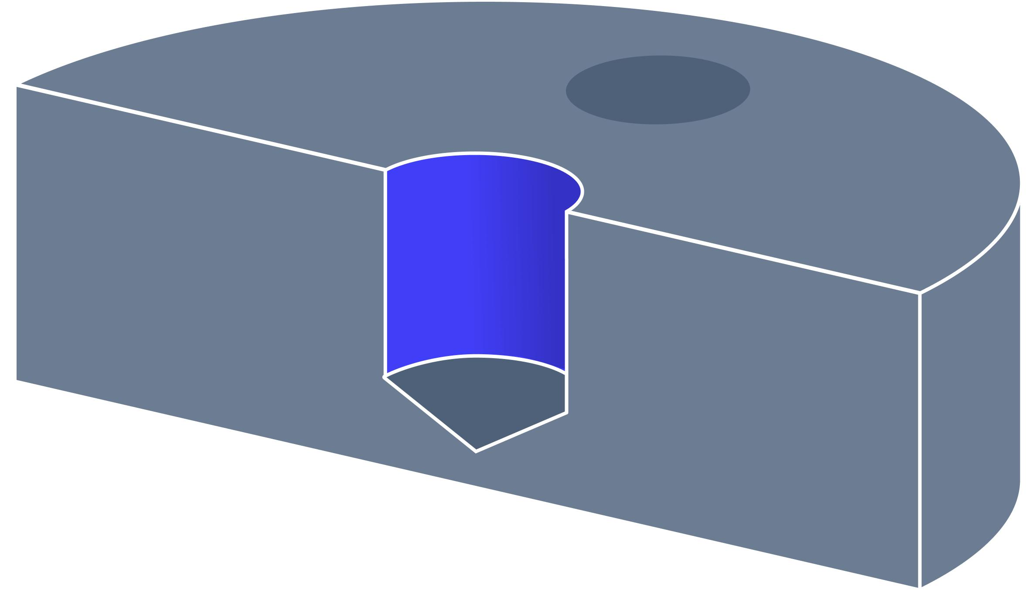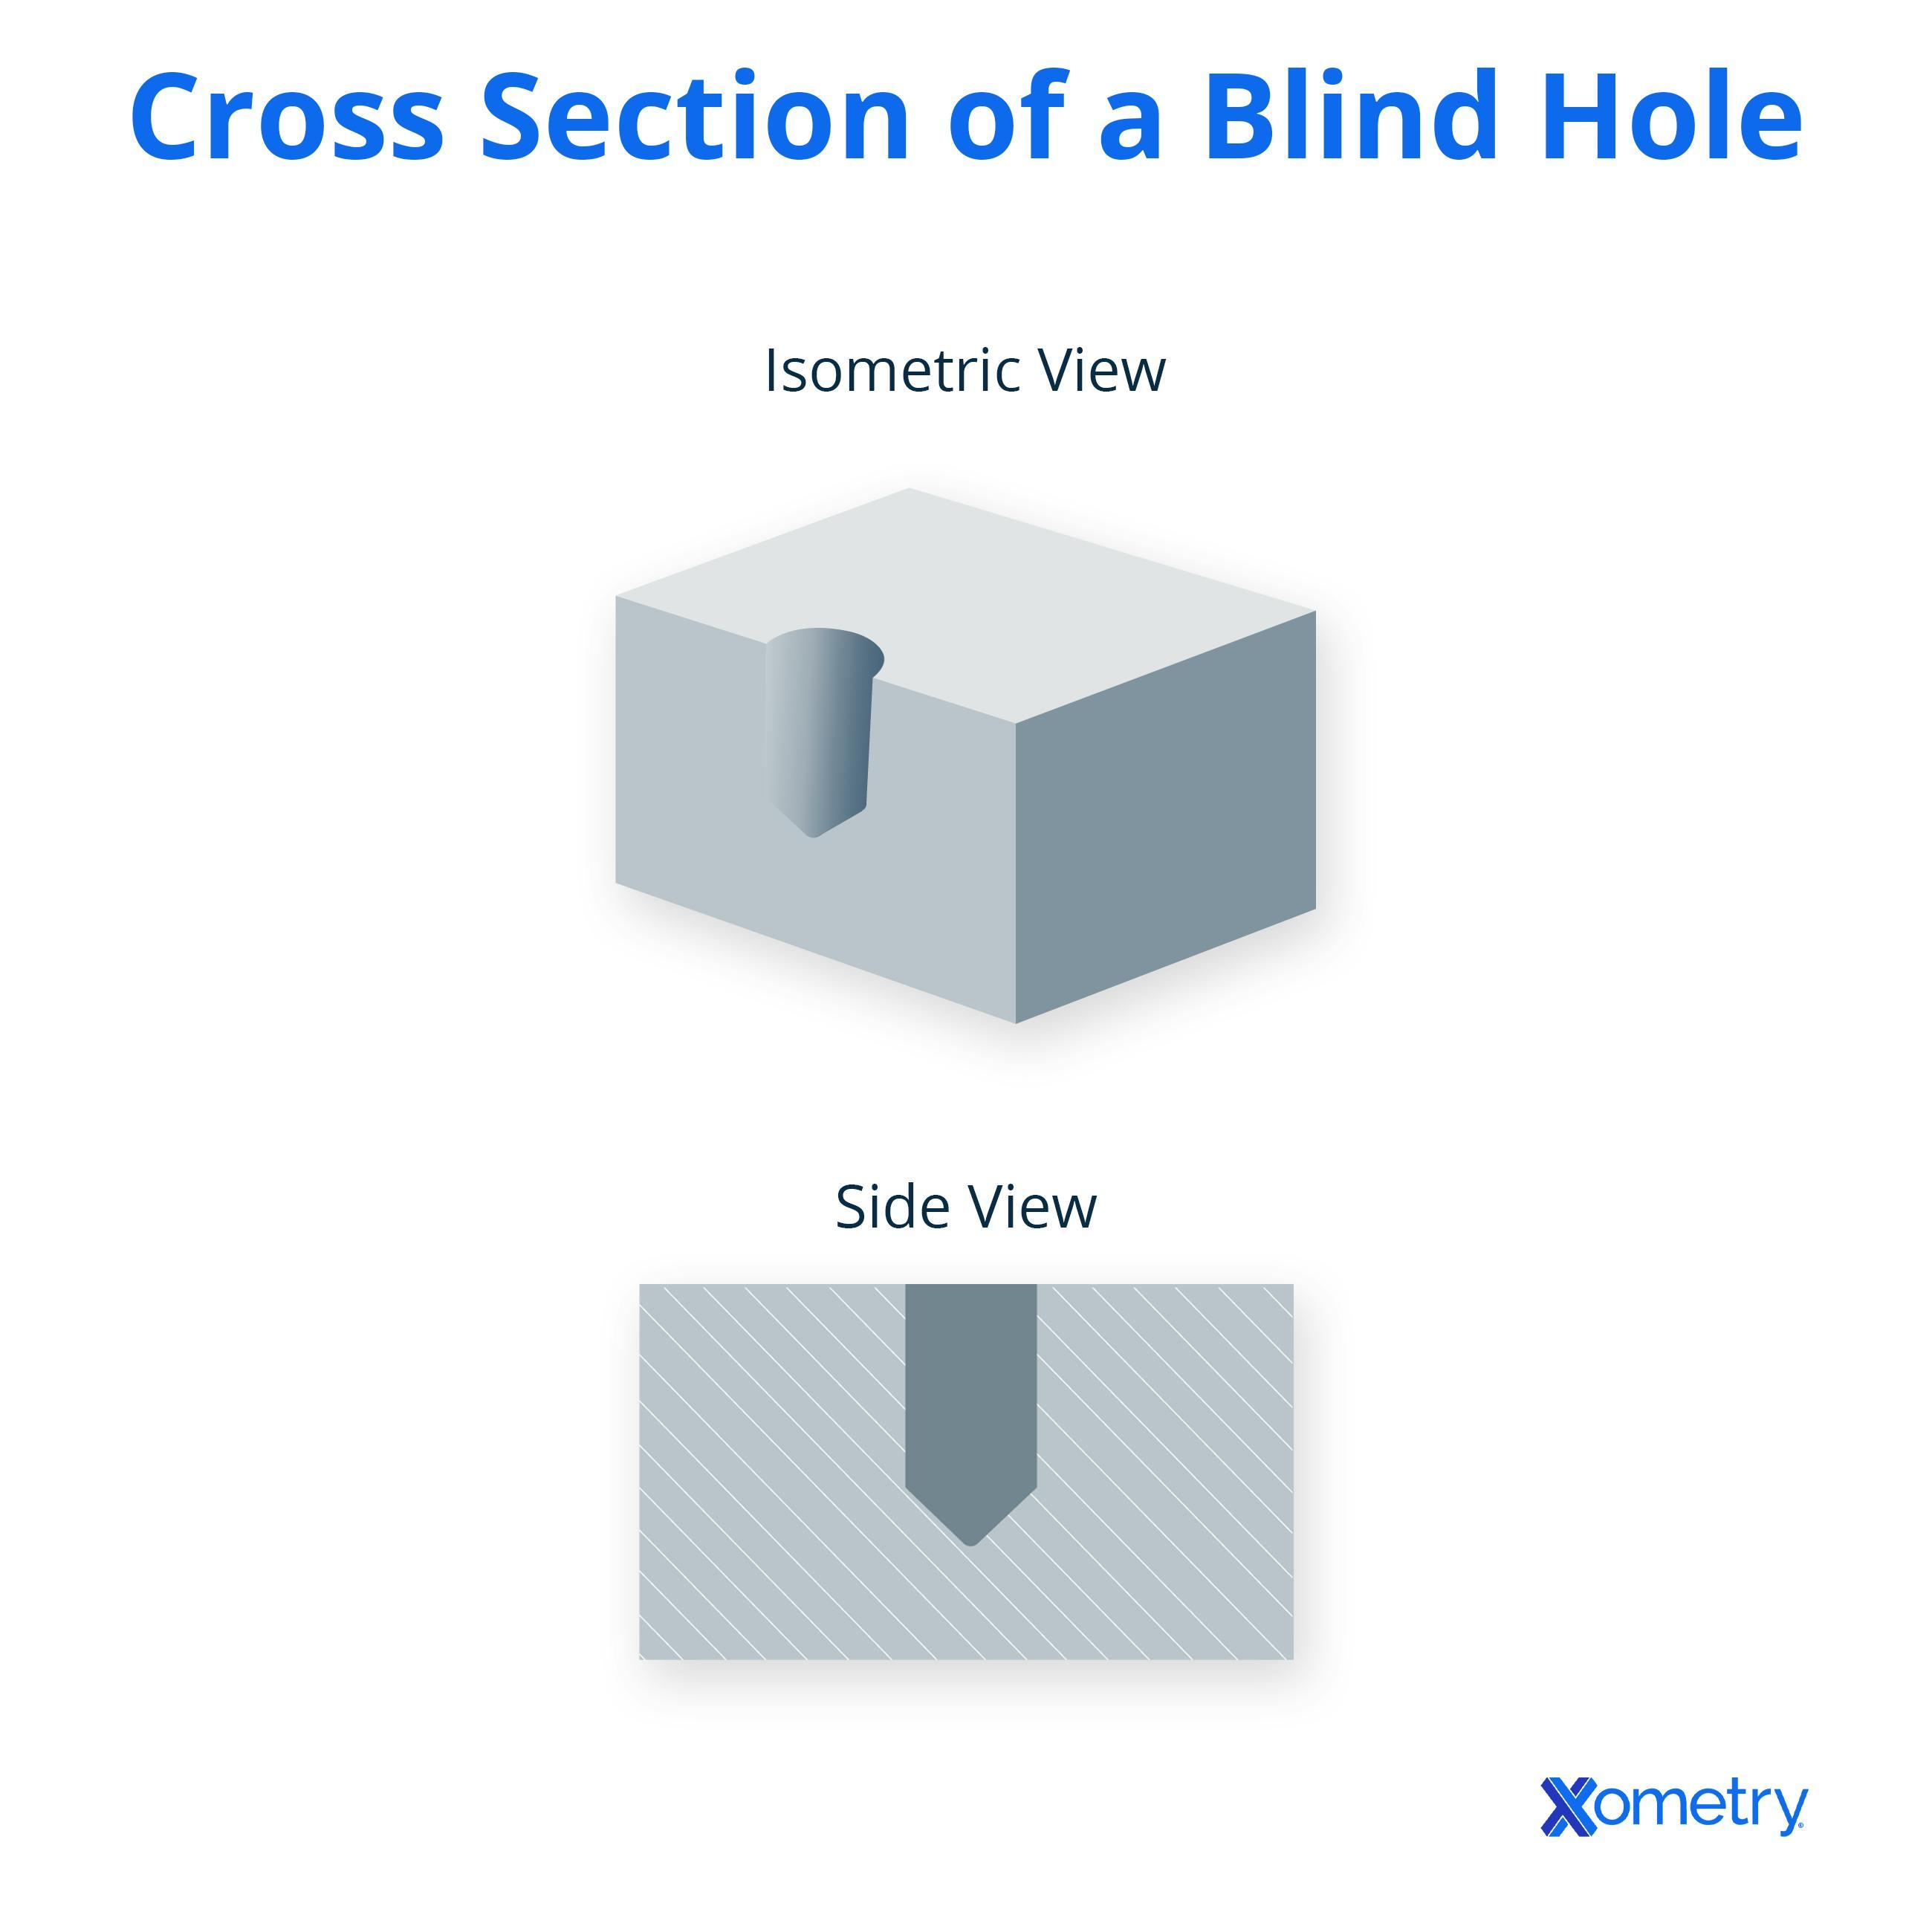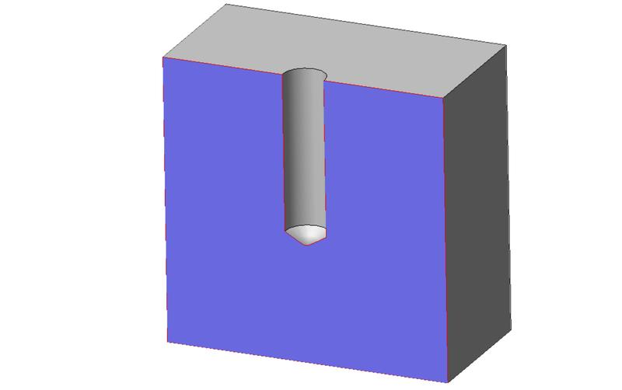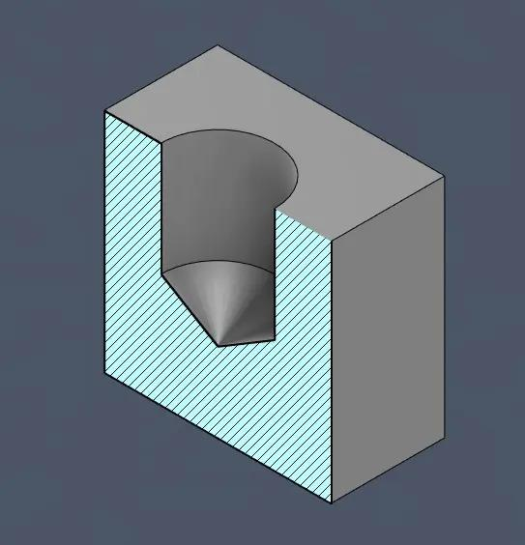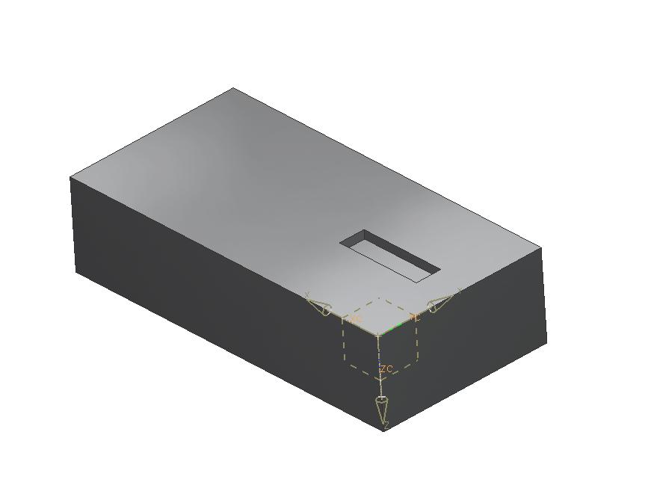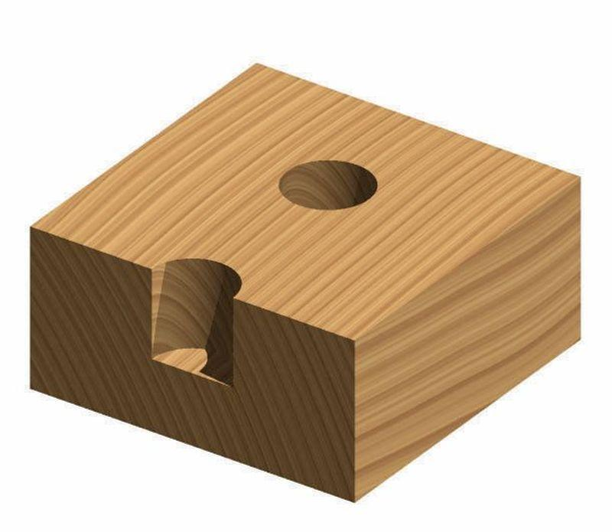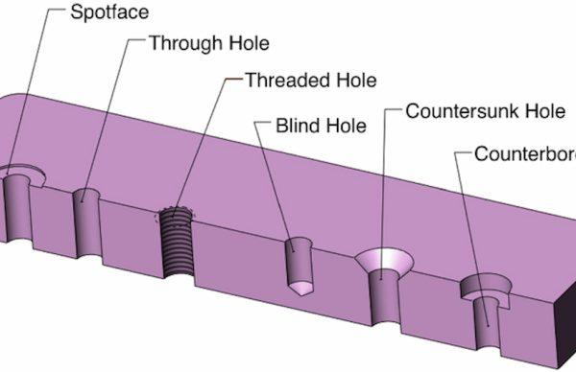

Main Classification

Types of Blind-Hole Subtraction
# Source: AI Source: Provided by: [Data Path: Persons Table -> ID Column: 1, Name_En Column: Motasem Essam] -> From: [ChatGPT] on [7/25/2026]

Cylindrical Blind-Hole Subtraction
# Source: AI Source: Provided by: [Data Path: Persons Table -> ID Column: 1, Name_En Column: Motasem Essam] -> From: [ChatGPT] on [7/25/2026]
Material is removed using a cylindrical region that extends partially into the original solid.
Examples:
- Circular blind hole in a rectangular prism.
- Cylindrical hole in a cube.
- Multiple cylindrical blind holes in one solid.

Rectangular Blind-Hole Subtraction
# Source: AI Source: Provided by: [Data Path: Persons Table -> ID Column: 1, Name_En Column: Motasem Essam] -> From: [ChatGPT] on [7/25/2026]
Material is removed using a rectangular-prism-shaped region that extends partially into the original solid.
Examples:
- Rectangular blind hole in a cube.
- Rectangular recess in a prism.
- Deep rectangular pocket in a block.

Square Blind-Hole Subtraction
# Source: AI Source: Provided by: [Data Path: Persons Table -> ID Column: 1, Name_En Column: Motasem Essam] -> From: [ChatGPT] on [7/25/2026]
Material is removed using a square-prism-shaped region that extends partially into the solid.
Examples:
- Square hole in a cube.
- Square recess in a rectangular prism.
- Multiple square blind holes in a solid block.
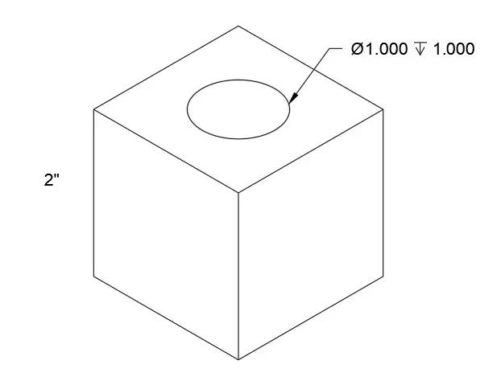

Triangular Blind-Hole Subtraction
# Source: AI Source: Provided by: [Data Path: Persons Table -> ID Column: 1, Name_En Column: Motasem Essam] -> From: [ChatGPT] on [7/25/2026]
Material is removed using a triangular-prism-shaped region that extends partially into the original solid.
Examples:
- Triangular blind opening in a rectangular prism.
- Triangular recess in a cube.
- Deep triangular pocket in a solid.
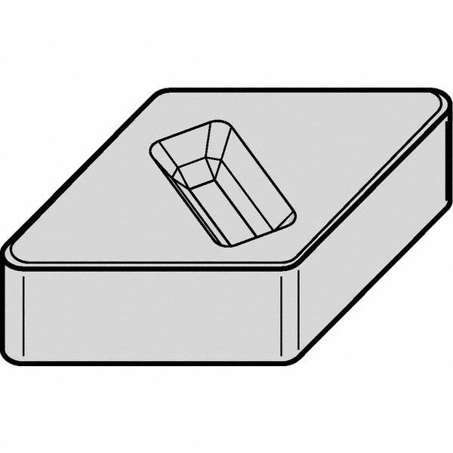

Polygonal Blind-Hole Subtraction
# Source: AI Source: Provided by: [Data Path: Persons Table -> ID Column: 1, Name_En Column: Motasem Essam] -> From: [ChatGPT] on [7/25/2026]
Material is removed using a prism-shaped region with a polygonal cross-section.
Examples:
- Pentagonal blind hole.
- Hexagonal blind hole.
- Octagonal blind hole.
- Irregular polygonal blind opening.
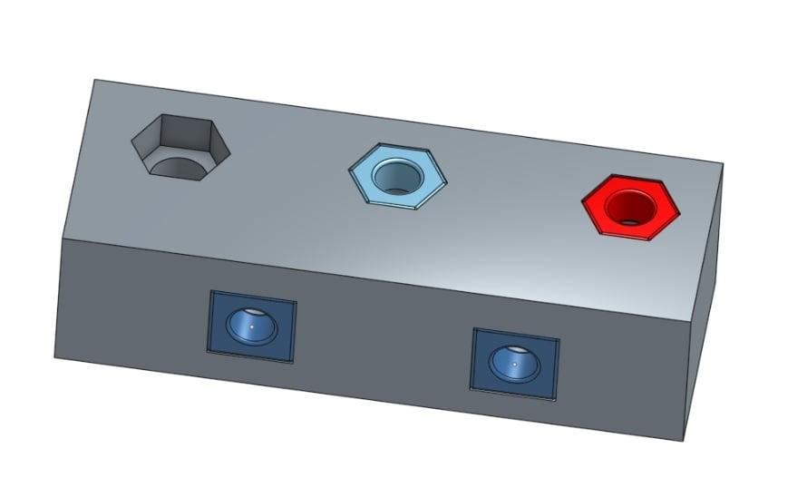

Conical Blind-Hole Subtraction
# Source: AI Source: Provided by: [Data Path: Persons Table -> ID Column: 1, Name_En Column: Motasem Essam] -> From: [ChatGPT] on [7/25/2026]
Material is removed using a conical region that ends inside the original solid.
Examples:
- Conical blind recess.
- Tapered blind hole.
- Pointed-bottom conical opening.

Stepped Blind-Hole Subtraction
# Source: AI Source: Provided by: [Data Path: Persons Table -> ID Column: 1, Name_En Column: Motasem Essam] -> From: [ChatGPT] on [7/25/2026]
Material is removed using two or more connected sections with different cross-sectional dimensions or shapes, ending inside the solid.
Examples:
- Large cylindrical recess connected to a smaller cylindrical hole.
- Counterbore blind hole.
- Stepped rectangular blind pocket.
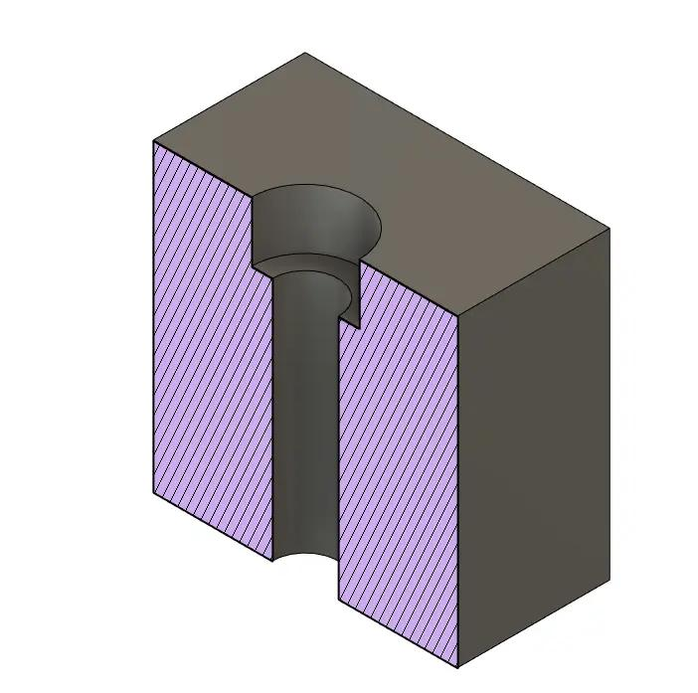

Mixed-Shape Blind-Hole Subtraction
# Source: AI Source: Provided by: [Data Path: Persons Table -> ID Column: 1, Name_En Column: Motasem Essam] -> From: [ChatGPT] on [7/25/2026]
Material is removed using a passage or cavity containing two or more different cross-sectional shapes.
Examples:
- Circular opening connected to a rectangular internal recess.
- Cylindrical opening with a conical bottom.
- Polygonal entrance connected to a cylindrical blind hole.
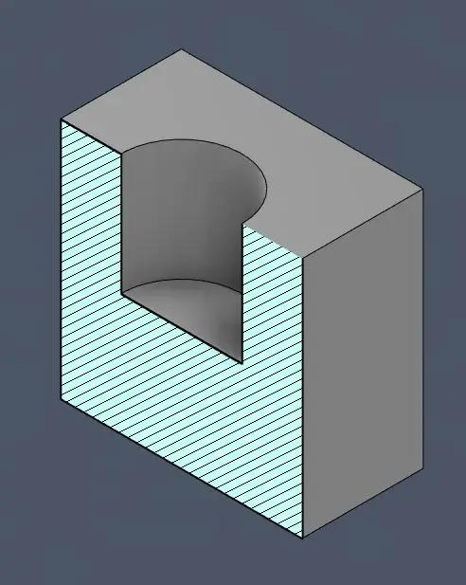

Classification by Hole Direction
# Source: AI Source: Provided by: [Data Path: Persons Table -> ID Column: 1, Name_En Column: Motasem Essam] -> From: [ChatGPT] on [7/25/2026]
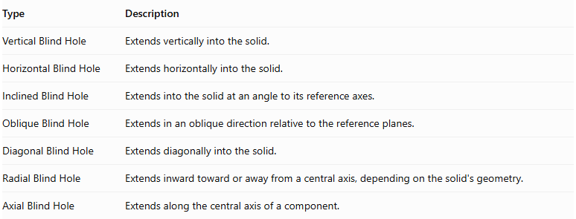
Type | Description
Vertical Blind Hole | Extends vertically into the solid.
Horizontal Blind Hole | Extends horizontally into the solid.
Inclined Blind Hole | Extends into the solid at an angle to its reference axes.
Oblique Blind Hole | Extends in an oblique direction relative to the reference planes.
Diagonal Blind Hole | Extends diagonally into the solid.
Radial Blind Hole | Extends inward toward or away from a central axis, depending on the solid's geometry.
Axial Blind Hole | Extends along the central axis of a component.
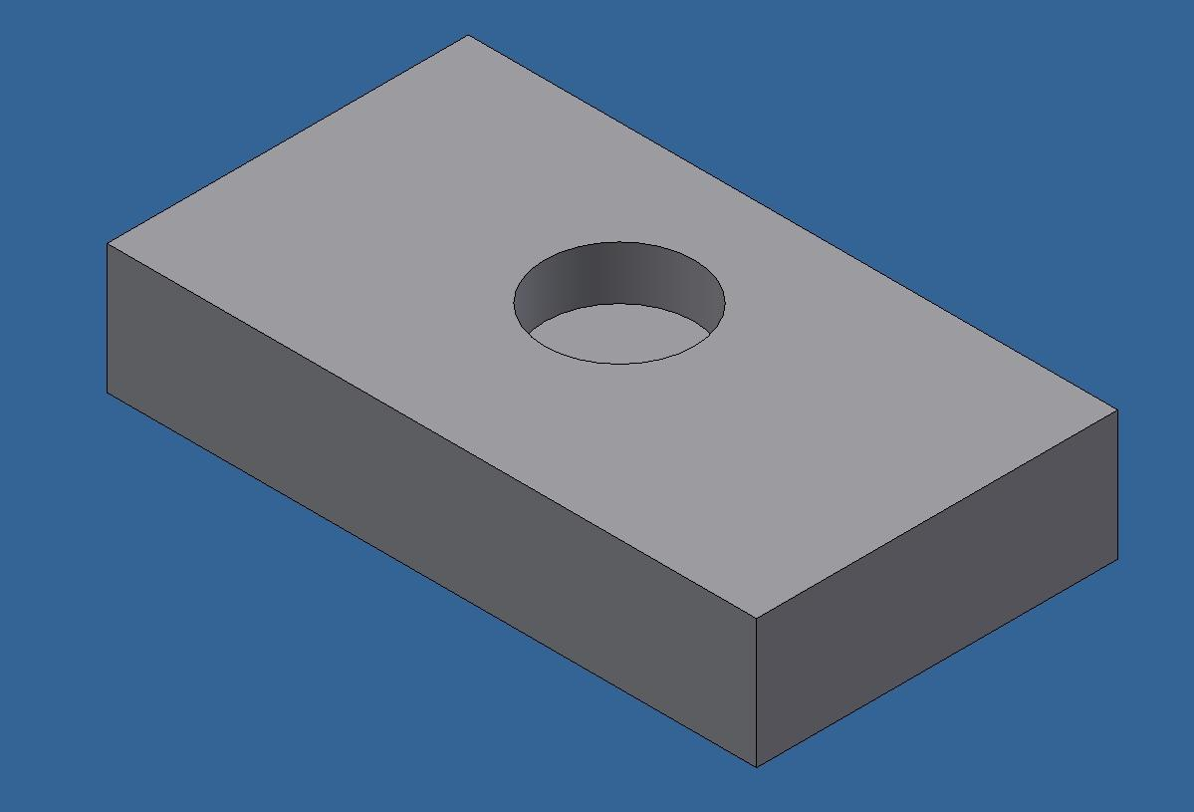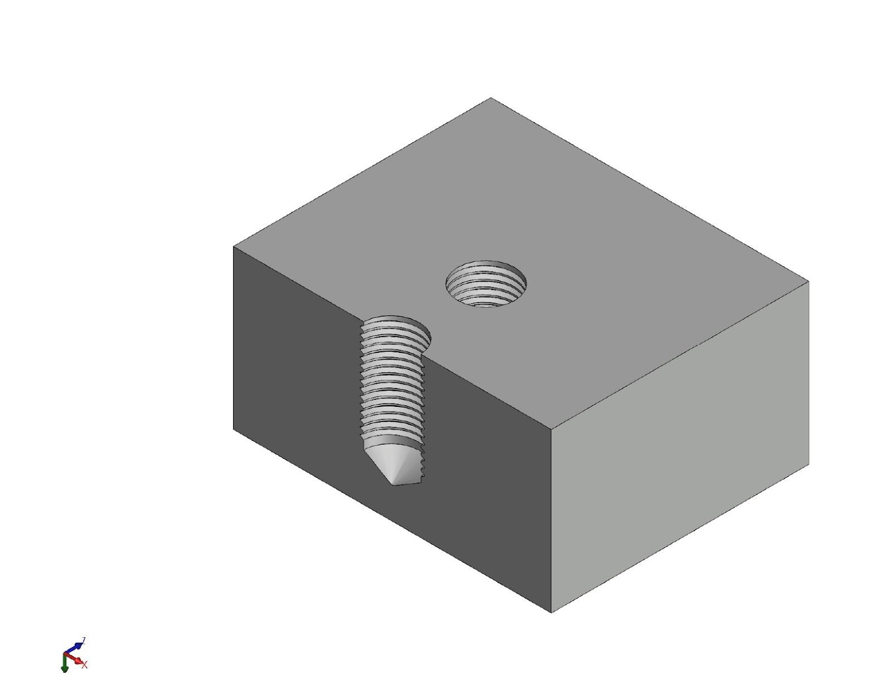

Classification by Number of Holes
# Source: AI Source: Provided by: [Data Path: Persons Table -> ID Column: 1, Name_En Column: Motasem Essam] -> From: [ChatGPT] on [7/25/2026]
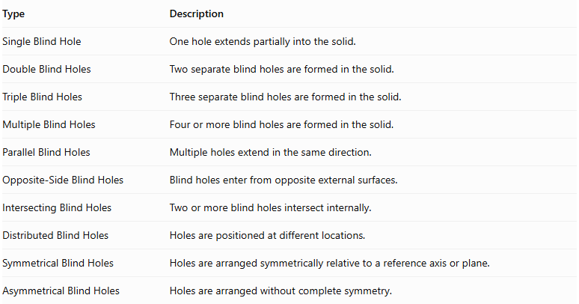
Type | Description
Single Blind Hole | One hole extends partially into the solid.
Double Blind Holes | Two separate blind holes are formed in the solid.
Triple Blind Holes | Three separate blind holes are formed in the solid.
Multiple Blind Holes | Four or more blind holes are formed in the solid.
Parallel Blind Holes | Multiple holes extend in the same direction.
Opposite-Side Blind Holes | Blind holes enter from opposite external surfaces.
Intersecting Blind Holes | Two or more blind holes intersect internally.
Distributed Blind Holes | Holes are positioned at different locations.
Symmetrical Blind Holes | Holes are arranged symmetrically relative to a reference axis or plane.
Asymmetrical Blind Holes | Holes are arranged without complete symmetry.
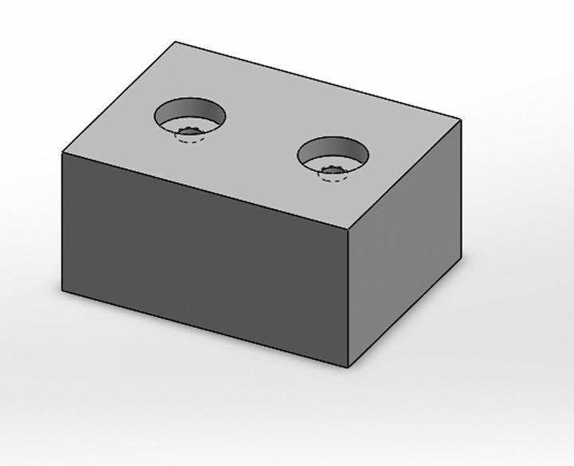

Classification by Bottom Shape
# Source: AI Source: Provided by: [Data Path: Persons Table -> ID Column: 1, Name_En Column: Motasem Essam] -> From: [ChatGPT] on [7/25/2026]
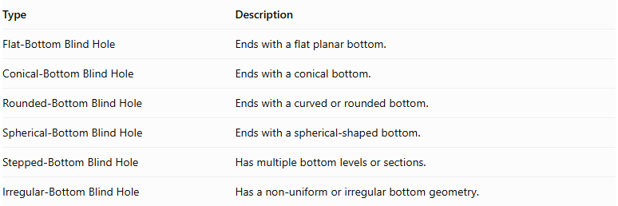
Type | Description
Flat-Bottom Blind Hole | Ends with a flat planar bottom.
Conical-Bottom Blind Hole | Ends with a conical bottom.
Rounded-Bottom Blind Hole | Ends with a curved or rounded bottom.
Spherical-Bottom Blind Hole | Ends with a spherical-shaped bottom.
Stepped-Bottom Blind Hole | Has multiple bottom levels or sections.
Irregular-Bottom Blind Hole | Has a non-uniform or irregular bottom geometry.
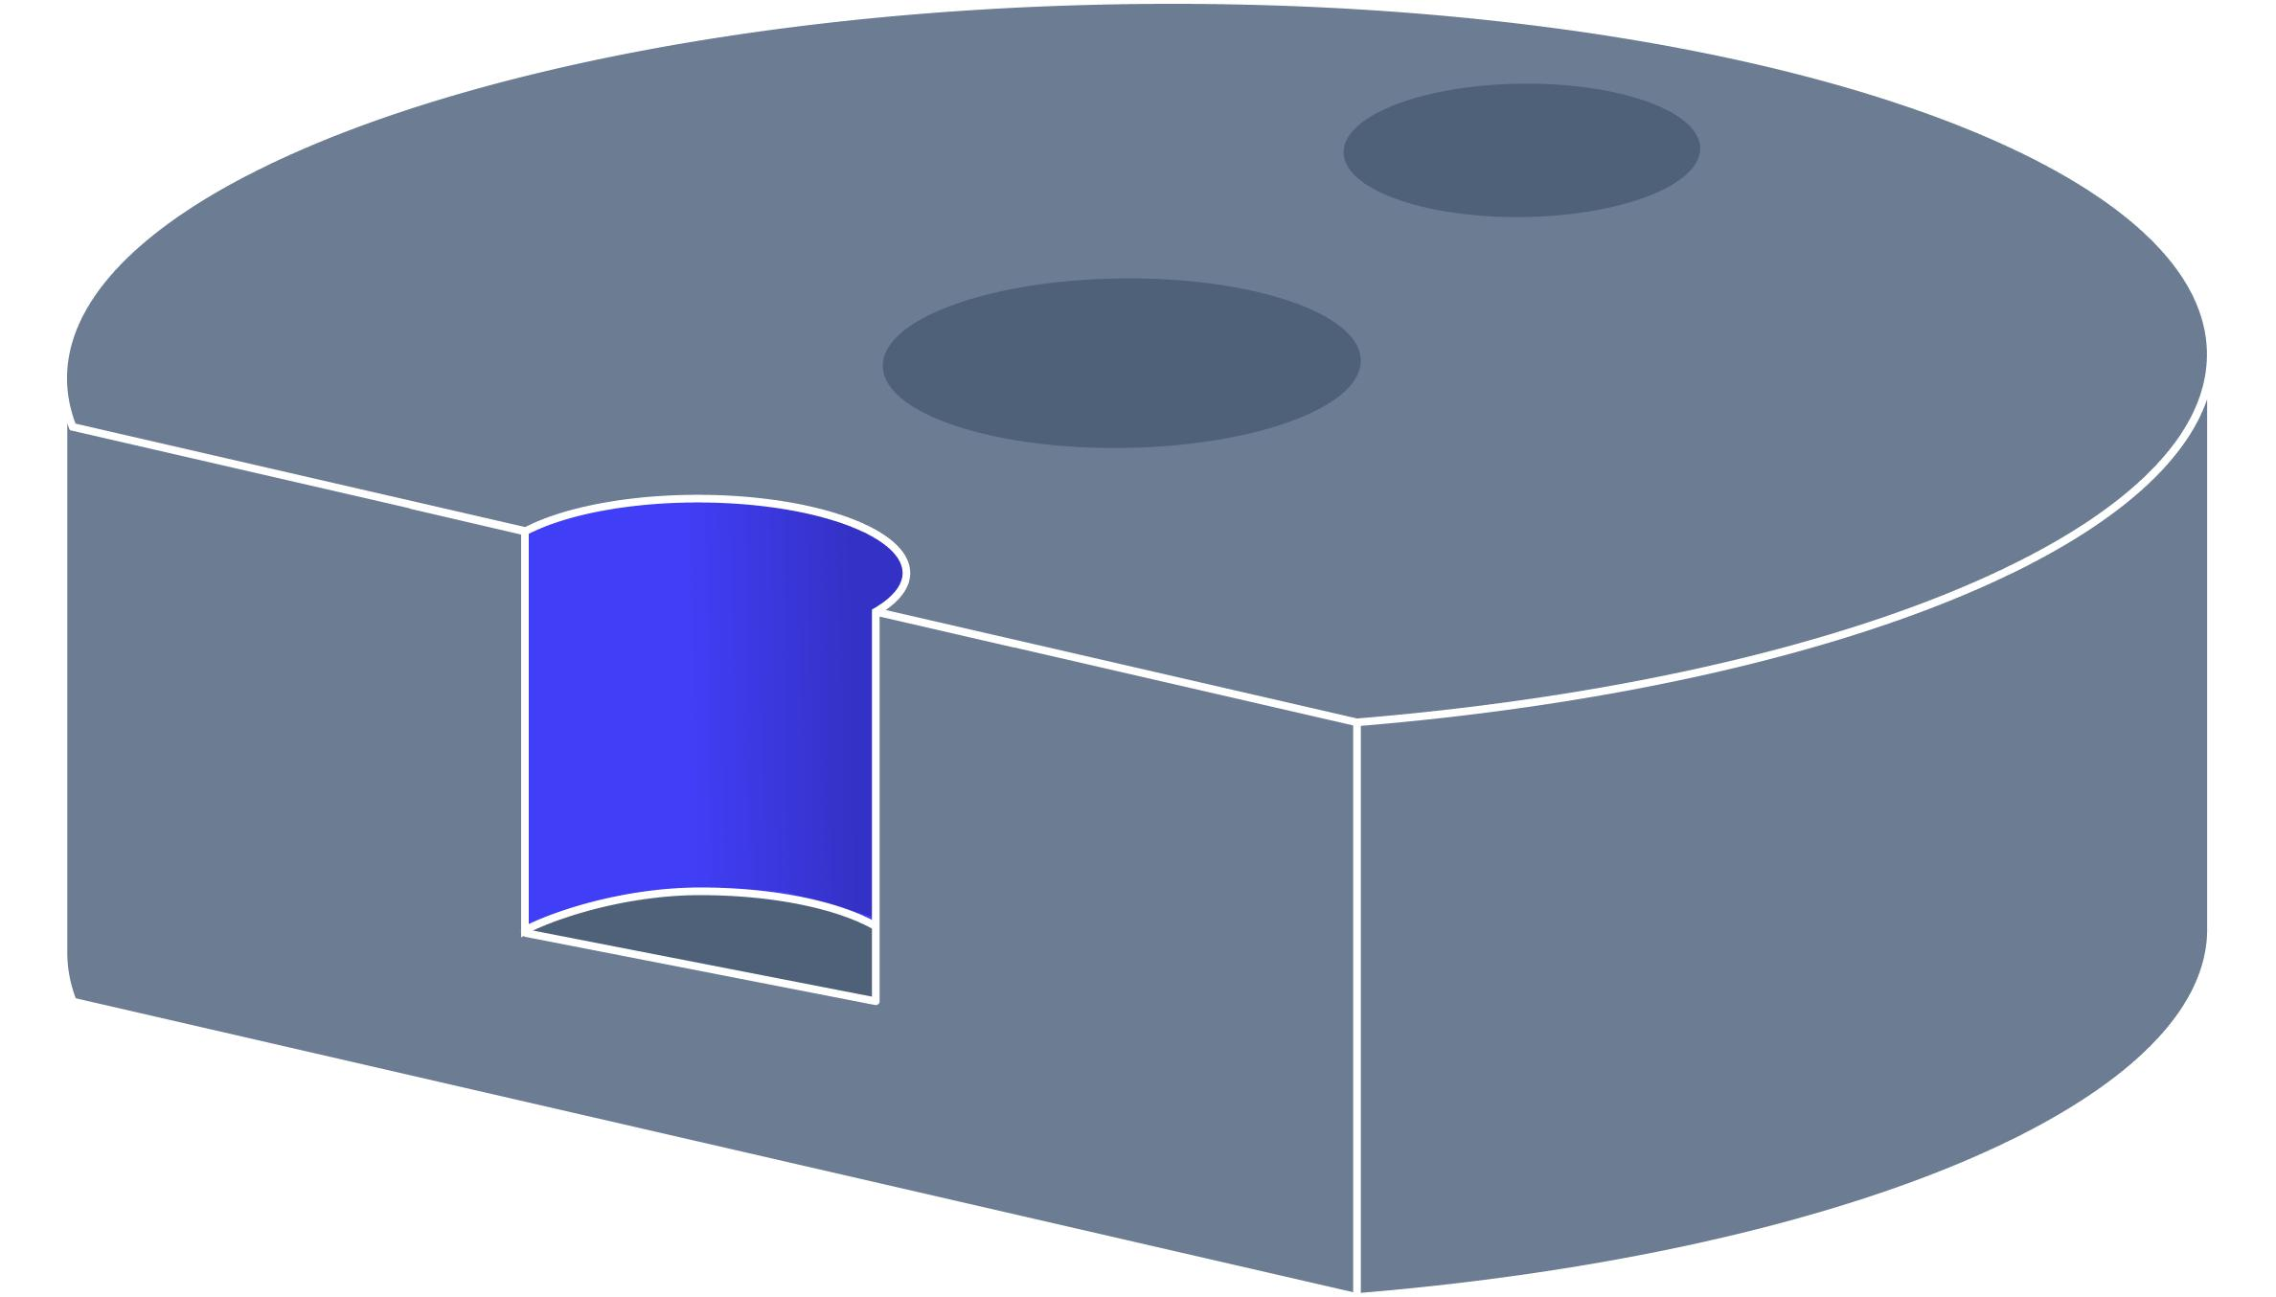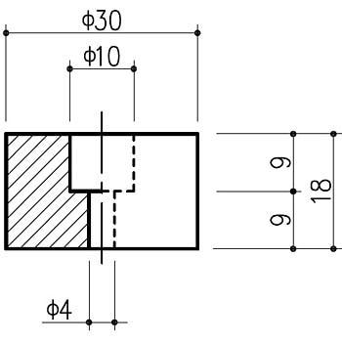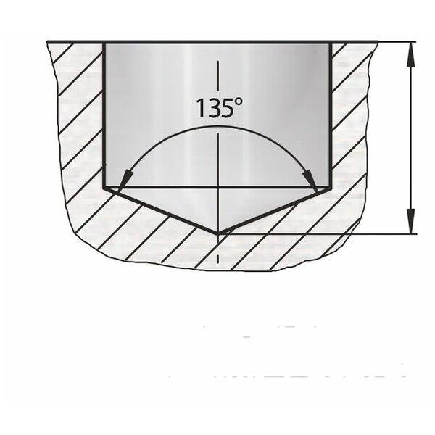

Classification by Cross-Sectional Shape
# Source: AI Source: Provided by: [Data Path: Persons Table -> ID Column: 1, Name_En Column: Motasem Essam] -> From: [ChatGPT] on [7/25/2026]
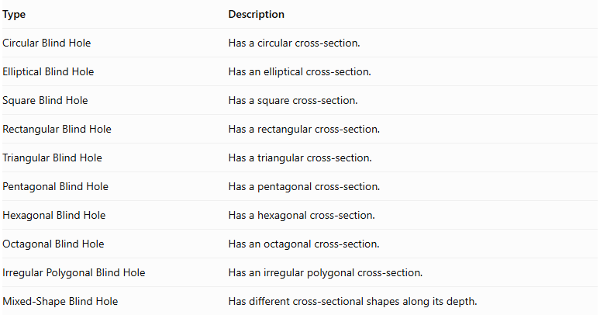
Type | Description
Circular Blind Hole | Has a circular cross-section.
Elliptical Blind Hole | Has an elliptical cross-section.
Square Blind Hole | Has a square cross-section.
Rectangular Blind Hole | Has a rectangular cross-section.
Triangular Blind Hole | Has a triangular cross-section.
Pentagonal Blind Hole | Has a pentagonal cross-section.
Hexagonal Blind Hole | Has a hexagonal cross-section.
Octagonal Blind Hole | Has an octagonal cross-section.
Irregular Polygonal Blind Hole | Has an irregular polygonal cross-section.
Mixed-Shape Blind Hole | Has different cross-sectional shapes along its depth.

Mathematical Properties and Formulas
# Source: AI Source: Provided by: [Data Path: Persons Table -> ID Column: 1, Name_En Column: Motasem Essam] -> From: [ChatGPT] on [7/25/2026]
The volume and surface area depend on the original solid, the hole's cross-sectional shape, its depth, and its bottom geometry.

Volume
# Source: AI Source: Provided by: [Data Path: Persons Table -> ID Column: 1, Name_En Column: Motasem Essam] -> From: [ChatGPT] on [7/25/2026]
The remaining volume is calculated by subtracting the removed volume from the original solid.
$$V_{remaining}=V_{original}-V_{hole}$$
For multiple non-overlapping blind holes:
$$V_{remaining}=V_{original}-\sum_{i=1}^{n}{V_{{hole}_{i}}}$$
If holes overlap internally, their intersection volumes must be accounted for to avoid subtracting the same region more than once.

Cylindrical Blind Hole
# Source: AI Source: Provided by: [Data Path: Persons Table -> ID Column: 1, Name_En Column: Motasem Essam] -> From: [ChatGPT] on [7/25/2026]
For a cylindrical blind hole with a flat bottom:
$$V_{hole}=πr^{2}h$$
Where:
- $r$ = Radius of the hole.
- $h$ = Depth of the hole.
Therefore:
$$V_{remaining}=V_{original}-πr^{2}h$$

Conical Blind Hole
# Source: AI Source: Provided by: [Data Path: Persons Table -> ID Column: 1, Name_En Column: Motasem Essam] -> From: [ChatGPT] on [7/25/2026]
For a conical blind hole:
$$V_{hole}=\frac{1}{3}πr^{2}h$$
Where:
- $r$ = Radius of the opening.
- $h$ = Depth of the conical region.

Rectangular Blind Hole
# Source: AI Source: Provided by: [Data Path: Persons Table -> ID Column: 1, Name_En Column: Motasem Essam] -> From: [ChatGPT] on [7/25/2026]
For a rectangular-prism-shaped blind hole:
$$V_{hole}=lwh$$
Where:
- $l$ = Length of the opening.
- $w$ = Width of the opening.
- $h$ = Depth of the hole.

Surface Area
# Source: AI Source: Provided by: [Data Path: Persons Table -> ID Column: 1, Name_En Column: Motasem Essam] -> From: [ChatGPT] on [7/25/2026]
Blind-hole subtraction changes the surface area because it:
- Removes the original opening region from the external surface.
- Creates new internal lateral surfaces.
- Creates a new bottom surface inside the original solid.
For a cylindrical blind hole with a flat bottom passing perpendicularly into a flat surface:
$${SA}_{remaining}={SA}_{original}-πr^{2}+2πrh+πr^{2}$$
The removed circular opening and the newly exposed circular bottom have equal areas, so they cancel:
$$\boxed{{SA}_{remaining}={SA}_{original}+2πrh}$$
This formula assumes the cylindrical hole is completely contained within the original face, has a flat bottom, and does not intersect other holes or external boundaries.

Worked Examples

Example 1: Cylindrical Blind Hole in a Rectangular Prism
# Source: AI Source: Provided by: [Data Path: Persons Table -> ID Column: 1, Name_En Column: Motasem Essam] -> From: [ChatGPT] on [7/25/2026]
A cylindrical blind hole is created vertically in a rectangular prism.
The dimensions are:
- Length = 10 cm
- Width = 8 cm
- Height = 6 cm
- Hole radius = 2 cm
- Hole depth = 4 cm
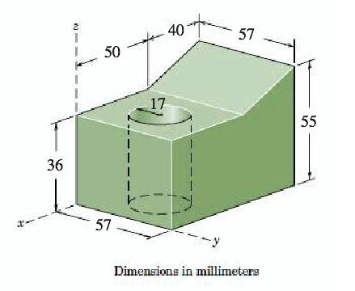
Step 1: Calculate the original volume.
$$V_{original}=lwh$$
$$V_{original}=10×8×6$$
$$V_{original}=480{ cm}^{3}$$
Step 2: Calculate the removed cylindrical volume.
$$V_{hole}=πr^{2}h$$
$$V_{hole}=π(2)^{2}(4)$$
$$V_{hole}=16π$$
Step 3: Calculate the remaining volume.
$$V_{remaining}=480-16π$$
$$\boxed{V_{remaining}≈429.73{ cm}^{3}}$$
Step 4: Calculate the original surface area.
$${SA}_{original}=2(lw+lh+wh)$$
$${SA}_{original}=2(80+60+48)$$
$${SA}_{original}=376{ cm}^{2}$$
Step 5: Calculate the remaining surface area.
The circular opening is removed, a circular bottom is exposed, and the cylindrical internal wall is added.
$${SA}_{remaining}=376-π(2)^{2}+2π(2)(4)+π(2)^{2}$$
$${SA}_{remaining}=376+16π$$
$$\boxed{{SA}_{remaining}≈426.27{ cm}^{2}}$$

Example 2: Rectangular Blind Hole in a Cube
# Source: AI Source: Provided by: [Data Path: Persons Table -> ID Column: 1, Name_En Column: Motasem Essam] -> From: [ChatGPT] on [7/25/2026]
A rectangular blind hole is cut into the top face of a cube.
The dimensions are:
- Cube side length = 10 cm
- Hole length = 4 cm
- Hole width = 3 cm
- Hole depth = 5 cm
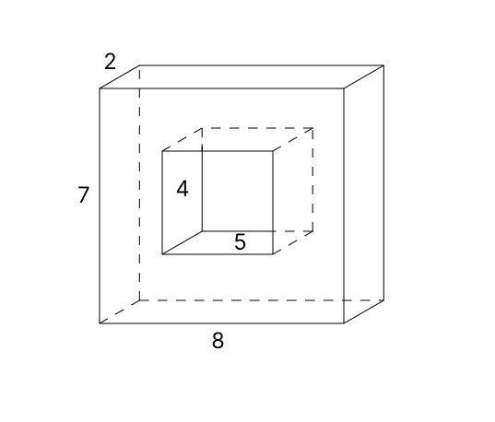
Step 1: Calculate the original cube volume.
$$V_{original}=a^{3}$$
$$V_{original}={10}^{3}=1000{ cm}^{3}$$
Step 2: Calculate the removed volume.
$$V_{hole}=lwh$$
$$V_{hole}=4×3×5$$
$$V_{hole}=60{ cm}^{3}$$
Step 3: Calculate the remaining volume.
$$V_{remaining}=1000-60$$
$$\boxed{V_{remaining}=940{ cm}^{3}}$$
Step 4: Calculate the original surface area.
$${SA}_{original}=6a^{2}$$
$${SA}_{original}=6(10)^{2}$$
$${SA}_{original}=600{ cm}^{2}$$
Step 5: Calculate the remaining surface area.
The removed rectangular opening and the new rectangular bottom have equal areas.
The four internal walls have areas:
$$A_{walls}=2(4×5)+2(3×5)$$
$$A_{walls}=40+30=70$$
Therefore:
$${SA}_{remaining}=600+70$$
$$\boxed{{SA}_{remaining}=670{ cm}^{2}}$$

Important Characteristics
# Source: AI Source: Provided by: [Data Path: Persons Table -> ID Column: 1, Name_En Column: Motasem Essam] -> From: [ChatGPT] on [7/25/2026]
- A blind hole extends only partially into the original solid.
- It has one entrance opening and a closed bottom.
- It does not pass completely through the original solid.
- Its depth is less than the available solid thickness along the hole direction.
- It may have a circular, rectangular, triangular, polygonal, or mixed cross-section.
- Its bottom may be flat, conical, rounded, or stepped.
- Multiple blind holes can exist in one solid.
- The removed volume is subtracted from the original volume.
- New internal walls and a bottom surface are created.
- The remaining material beneath the hole is preserved.

Comparison with Other Subtraction Methods
# Source: AI Source: Provided by: [Data Path: Persons Table -> ID Column: 1, Name_En Column: Motasem Essam] -> From: [ChatGPT] on [7/25/2026]
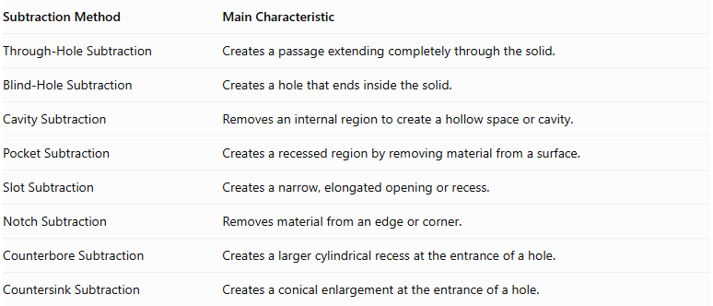
Subtraction Method | Main Characteristic
Through-Hole Subtraction | Creates a passage extending completely through the solid.
Blind-Hole Subtraction | Creates a hole that ends inside the solid.
Cavity Subtraction | Removes an internal region to create a hollow space or cavity.
Pocket Subtraction | Creates a recessed region by removing material from a surface.
Slot Subtraction | Creates a narrow, elongated opening or recess.
Notch Subtraction | Removes material from an edge or corner.
Counterbore Subtraction | Creates a larger cylindrical recess at the entrance of a hole.
Countersink Subtraction | Creates a conical enlargement at the entrance of a hole.
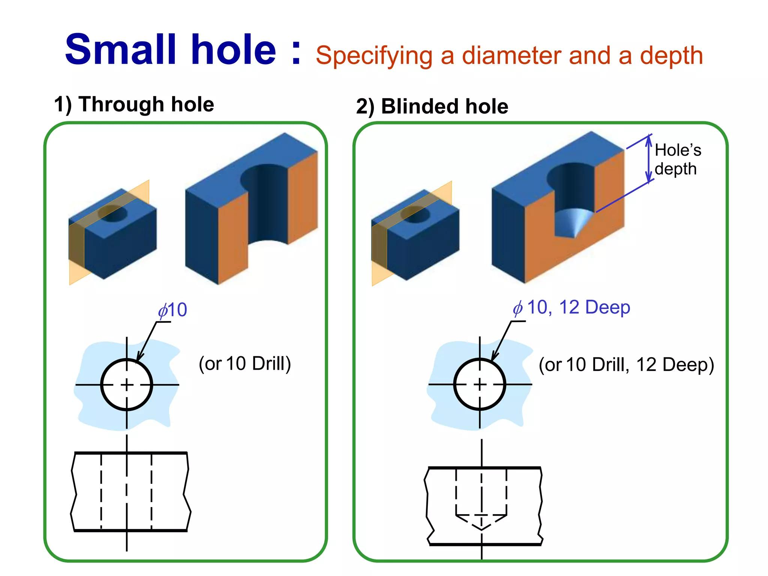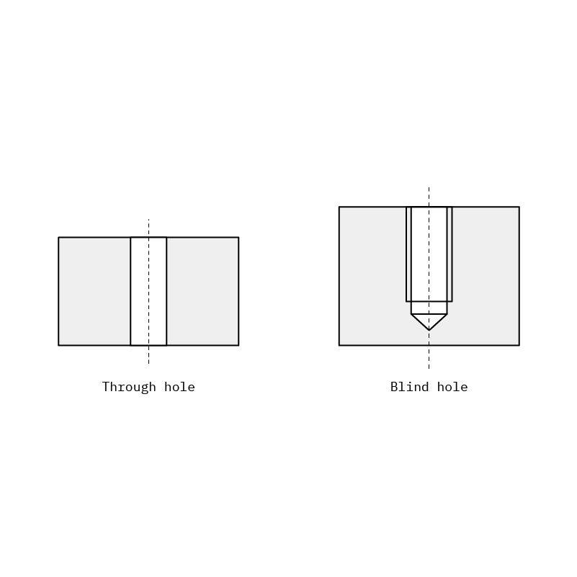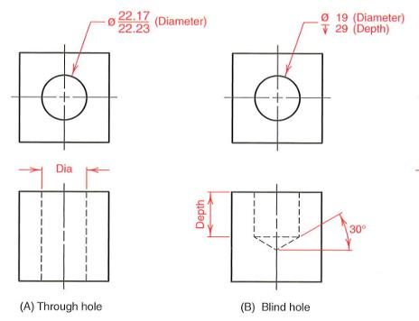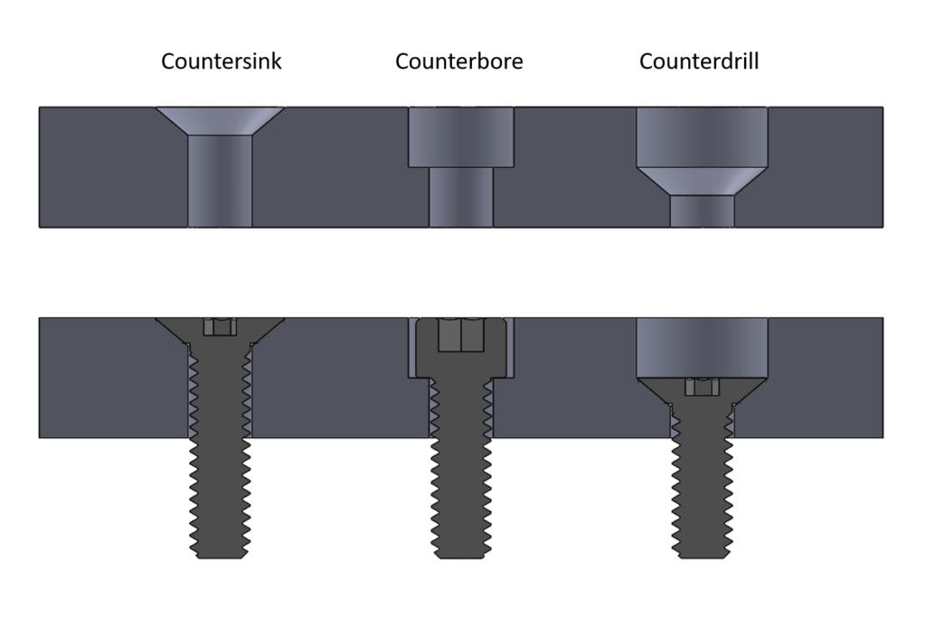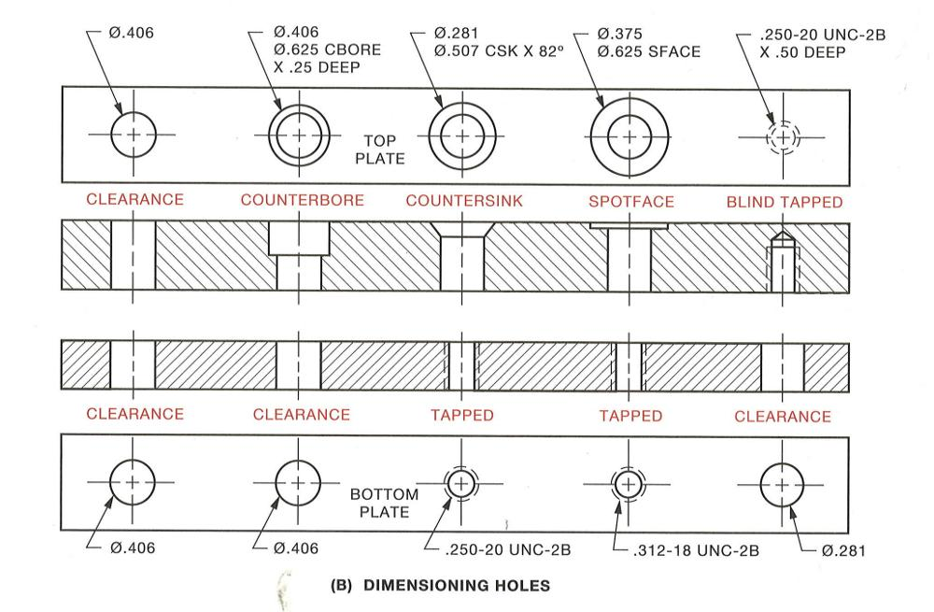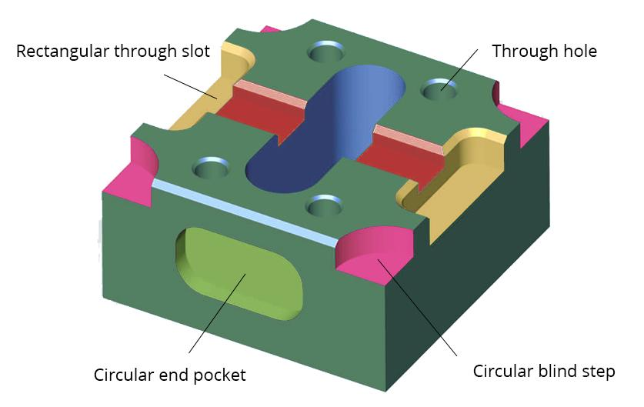

Applications
# Source: AI Source: Provided by: [Data Path: Persons Table -> ID Column: 1, Name_En Column: Motasem Essam] -> From: [ChatGPT] on [7/25/2026]
Blind-hole subtraction is commonly used in:
- Mechanical engineering.
- Screw and bolt mounting holes.
- Threaded holes in machine components.
- Manufacturing and machining.
- Recessed component housings.
- Furniture assembly.
- Mold and die construction.
- Three-dimensional CAD modeling.
- Industrial equipment and machine parts.

Key Points
# Source: AI Source: Provided by: [Data Path: Persons Table -> ID Column: 1, Name_En Column: Motasem Essam] -> From: [ChatGPT] on [7/25/2026]
- Blind-hole subtraction creates an opening that ends inside the original solid.
- The hole has one entrance and a closed bottom.
- It can have different cross-sectional shapes and bottom configurations.
- Its depth is smaller than the available thickness of the original solid.
- The remaining volume equals the original volume minus the removed volume.
- Its surface area includes the newly exposed internal walls and bottom.
- Unlike a through-hole, a blind hole preserves solid material beneath its bottom.

Conclusion
# Source: AI Source: Provided by: [Data Path: Persons Table -> ID Column: 1, Name_En Column: Motasem Essam] -> From: [ChatGPT] on [7/25/2026]
Blind-Hole Subtraction is a solid-modification method in which material is removed from an external surface to create a hole that extends only partially into the original solid. The hole has a defined depth and a closed bottom, distinguishing it from a through-hole. Blind holes may have different cross-sectional shapes, directions, and bottom configurations, making them useful in geometric modeling, mechanical design, and manufacturing.

